Python - Lab Exercise 1 (in Class)
Due Date : In Class (5 pts)

Instruction (Ask for guidance if necessary):
- Download the lab. To speed up the process, follow these steps.
  - Copy the CS1010 Lab1 f2018 mats folder from canvas
  - Open and move the ###_### Lab1F2018 folder from the zipped folder ONTO THE DESKTOP!!!
YOU CAN NOT MAKE CHANGES IF THE LAB FOLDER IS INSIDE THE ZIPPED FOLDER
  - Rename the folder with your class codes instead of the ### signs
  - Open the folder and rename both files with your class codes instead of the ### signs

B. Complete the lab
1. Start Pyscripter.
2. Choose the menu option File | Open
3. Select desktop, open your lab folder and then open the file with the .py extension.
4. Once you see this screen, Add your class time and class codes to the provided comments.
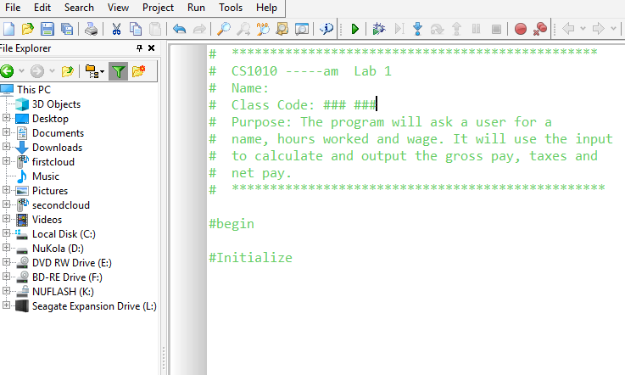

5. Enter the rest of the code found on the next page. Make sure you enter the code against the margin as it appears

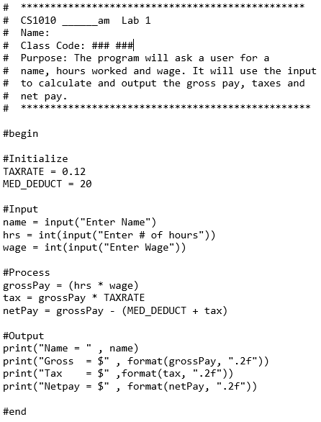

6. Select Run | Syntax Check and fix any errors
7. Select Run | Run to execute your lab
Enter Name: One partner’s class code and name
Enter # of hours: 42
Enter Wage: 27
8. Inside of your lab 1 folder, there is a word file to save snippets of your output
a. Use the snipping tool , ask anyone for help locating it, to snip the output of your program.
- if you can’t see the entire output, drag the code window up by clicking on the dots in the middle
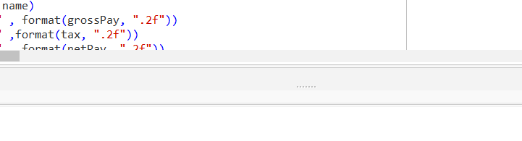

b. Open the ###_###Snipped Output.docx file and copy your output into the file. Save the file and close.

9. Creating a zip file to upload your lab unto canvas
a. save and close your lab
b. right click on the lab folder on the desktop and select send to, compressed (zipped) folder.
c. open your mybgsu portal and navigate to your cs1010 class on canvas
d. click on the Assignment tab and then the lab1 link.
e. select the upload option and upload your zipped folder.

No Need to Call me over, you are DONE!

